PFII/2010/EGM
Original: English

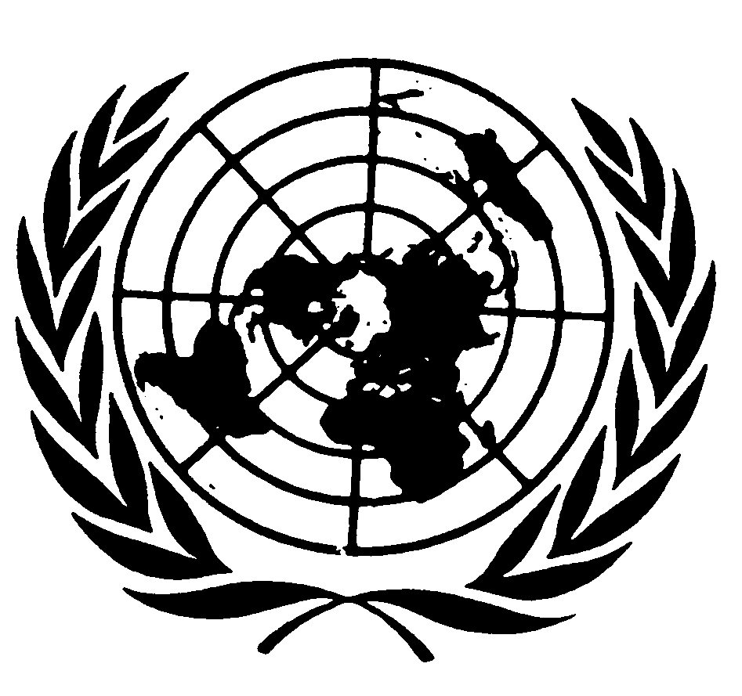
UNITED NATIONS NATIONS UNIES

DEPARTMENT OF ECONOMIC AND SOCIAL AFFAIRS
Division for Social Policy and Development
Secretariat of the Permanent Forum on Indigenous Issues

INTERNATIONAL EXPERT GROUP MEETING
Indigenous Peoples: Development with Culture and Identity
Articles 3 and 32 of the United Nations Declaration on the Rights of Indigenous Peoples
(New York, 12 - 14 January 2010)

Contribution by

Ms Jeannette C. Armstrong
En'owkin Centre
RR#2, Site 50, Comp. 8
Penticton, BC V2A 6J7

The focus that I provide is to outline the deeper fundamental truth regarding “Indigenous” peoples. Visiting this deeper truth provides an opportunity to locate my discussion around the broader issue of identity and culture for the discussion on the concept of development with identity and culture. I engage in this dialogue from a perspective expressed out of my own lived experience of “Indigeneity” as a Syilx Okanagan Person. From within that perspective, I provide comments on issues related to identity and Indigenous Peoples with a focus on identity and culture from within my experience in the position as one of the founders and director of an Indigenous Institute for Aboriginal Adults. The comments are presented for the purpose of participation in the International Expert Group Meeting on Indigenous Peoples: Development with Culture and identity: Articles 3 and 32 of the UN Declaration on the Rights of Indigenous Peoples.

Perhaps a distinction in my use of the term “Indigenous” is an appropriate place to situate my comments. At an earlier decade, Director General of UNESCO, Fredrico Mayor, defined Indigenous knowledge as “…an immense knowledge of their environment, based on centuries of living close to nature.” (Henderson, 2000). Paula Gunn Allen, a Native American writer, provides greater clarity in her description of that relationship, in her statement that “The land…is not the ever-present “Other” which supplies us with a sense of “I”. It is rather a part of our being…It is ourselves…it not a matter of being “close to nature”. (Henderson, 409) Melissa Nelson, in the introduction of Original Instructions: Indigenous Teachings for a Sustainable Future, states, “In this sense, our biological and psychological space is a communal ground, a commons…we cannot be separated from these places. The bones and blood of our ancestors have become the soil, the soil grows our food, the food nourishes our bodies, and we become one, literally and metaphorically, with our homelands and territories.” (Nelson, 10 08)

The distinction that I would wish to frame is the “Indigeneity” that I experience out on our tmxwulaxw, or land, gathering its bounty with my grandchildren and which forms the basis of my knowledge, my experience and therefore my identity and culture, as expressed through my Indigenous language. Through the words which produce the land’s “images” in my mind, in my Indigenous Nsyilxcen language, I “re-construct” being a part my “community” on my “land” in the land’s images and dynamics. That “re-construction” includes the physical, psychological and philosophical dimensions of being.

One of the issues confronting a less biased view of identity and culture is that definitions of “Indigenous” resides in an oppressive framework of systemic struggle based in “losses” and “recoveries” of control over Indigenous customs, laws, jurisdiction and tenures through various forms of colonization and imperialism. The measures taken to facilitate the process of unfettering “resources and lands” as well as managing aboriginal “claims”, as a process, effectively renders invisible the diversity and uniqueness of each Indigenous group as a People and effectively continues to “arrest” the practice of “Indigeneity” in relation to identity and culture. As a consequence, development initiatives of Indigenous Peoples, with, or related to culture and identity, will be impacted by the various frameworks of oppression.

Without the vitality of a unique relationship to their lands in an “in-situ” or lived experience of it, not only the social institutions and processes underpinning Indigenous political, legal and customary practices are lost, but the very basis of “Indigenous knowledge” is eroded and lost. As Battiste and Henderson explain in the Introduction to Protecting Indigenous Knowledge and Heritage: A Global Challenge, “We have experienced the colonization of our creations, our ecologies, our minds, and our spirits…Tragically, the struggle has left Indigenous peoples’ order, knowledge and languages vulnerable and endangered. Indigenous knowledge disappears when Indigenous peoples are stripped of their lands, their languages, and their lives.” (Battiste, 2004, 11)

Daryl Posey, in his essay Indigenous Ecological Knowledge, in speaking about the concept of “cultural landscapes” as a “merger between Nature and culture so complete it is impossible to separate the two” provided a view through a Cherokee person speaking about the cultural loss when Indigenous peoples are separated from land, “For the Cherokee, when a dam floods the land, it also destroys the medicines and the knowledge of the medicines associated with the land”. (Mander, 2005, 27) The losses of the lived experience of “Indigeneity” as relationship of people to land, is directly accompanied by the massive global loss of living nature. David Suzuki writes “…in the last century, Homo sapiens has undergone a radical transformation into a new kind of force…For the first time in the 3.8 billion years that life has existed on Earth, one species-humanity-is altering the biological, physical and chemical features of the planet on a geological scale.” (Suzuki, 1997, 11) Unbridled “development” in every form has unleashed escalating and compounding problems cumulatively producing a global crisis, both from a humanities perspective in the form of social injustices, as well as from the sciences view of the environment.

Although, Indigenous peoples living in land-based cultures, worldwide, remain the most vulnerable to all forms of corporate globalization, all communities and peoples are affected. As Jerry Mander comments in Paradigm Wars: Indigenous Peoples Resistance to Globalization, “In more ways than one, indigenous issues are the frontier issues of our time. They deal with geographic frontier struggles where the larger, destructive globalization process attempts to suck up the last living domains on the planet-its life forms, its basic resources, its peoples-in the empty cause of short-term wealth accumulation.” (Mander, 2005, 28)

One of the compounding factors requiring serious attention in the process of “protecting” Indigenous identity and thus their knowledge is also the loss of “Indigeneity” internally within Indigenous communities. Melissa Nelson characterizes the loss this way “…due to the trauma of colonization, assimilation and extreme poverty amid a capitalistic landscape, many Native Peoples have become “Americanized” with the same materialism as any one else”. The point is that is happening while others in the same communities struggle with maintaining their “Indigeneity” in terms of their relationships with the earth and nonhuman relatives, setting in place the conditions for economic disparities, corruption and strife. This is the fate of many Indigenous Peoples as “the political structures of oppression…become so dominant in the minds of the oppressed peoples that they begin to believe these dominant narratives and internalize the oppression.” (Nelson, 2008, 15-16) Indigenous peoples engaged in the daunting work to articulate and define requirements to protect and sustain their “Indigeneity” on their lands in this contemporary world, find a catch 22 situation in that “property rights” tools, structured by industrial economies, actually serve to deconstruct the authority and security of the “collective” authority safeguarding their commons with regard to culture and development. The outcome becomes a treacherous system of “individualization” of ownership and the ability to “capitalize” on collectively developed and collectively held rights. Indigenous rights held in an indigenous framework of traditions, customs and law in all situations are continually thwarted by systemic “oppression”.

Darrell Posey and Graham Dutfield point out in Beyond Intellectual Property: Toward Traditional Resource Rights For Indigenous Peoples and Local Communities, “…most governments are dualist (international law cannot be involved in their national courts)…makes it difficult for an Indigenous group to turn knowledge of International law into a strategy to have them implemented in their own country. ” (Posey, 2000, 118) However, despite the all of the faces of colonization, there has been a tremendous amount of on-going and historical resistance on the part of Indigenous peoples, expressed in the legacy of their struggles for the “protection” of their rights, their cultures and their livelihoods.

Indigenous identity and culture is significant, not just to Indigenous Peoples, but to the earth as a whole. As Mander succinctly points out, “Indigenous nations of the world sit on much of the planet’s remaining natural resource wealth. In itself, this is a testament to the long-term viability of their traditional values, and practices of stewardship, reciprocity, and integration with nature. It also confirms a highly advanced knowledge of how to be in the world; the rules, limits and practices of sustainability.” (Mander, 2005, 193) Henderson and Battiste inform, “The first problem in understanding Indigenous knowledge from a Eurocentric view is that Indigenous knowledge does not fit into the Eurocentric concept of “culture”. In contrast to colonial tradition, most Indigenous scholars choose to view every way of life from two different but complementary perspectives: First as a manifestation of human knowledge, heritage, and consciousness, and second as a mode of ecological order.” Battiste and Henderson go on to make the important distinction that “Based on our experience, we reject the concept of culture for Indigenous knowledge, heritage, and consciousness, and instead connect each Indigenous manifestation as part of a particular ecological order” (Battiste, 2000, 34) Battiste and Henderson add insight to the issue this way, “Survival for Indigenous peoples is more than a question of physical existence; it is an issue of preserving Indigenous knowledge systems in the face of cognitive imperialism. It is a global issue of maintaining Indigenous worldviews, languages, and environments. It is a matter of sustaining spiritual links with the land.” (Henderson, 2000, 12)

Development with identity and culture must be mindful that the practice of Indigeneity as a “whole system” is the best real protection for maintaining Indigenous identity and knowledge from loss, erosion and exploitation. A “whole-system” approach would require protecting all aspects of “Indigeneity” by developing protective measures and support structures to maintain, sustain and build on to the healthy inter-relationships of people and land within a viable contemporary context. There are many opportunities available for “collaborations” with Indigenous peoples desperately trying to live their Indigeneity “in-situ”, as well as those “re-indigenizing” through the recovery of practices, customs, the arts and languages in a contemporary context. The act of “collaboration” to develop “whole system” protection and support systems could induce radical shifts in government policy and in the application of development assistance to Indigenous Peoples. The act of “collaborating” with Indigenous peoples, on its own, would produce a transformative shift from a dominant framework of “control” toward instituting new ways of being. Such cooperation would be a crucial starting point of calling all peoples back to “Indigeneity” through forging new relationships of “coexistence” in land use practices and structuring new economies as a process of “restoring” Indigeneity to Peoples and lands.

The “shift” that constructing such mechanisms would require would be tantamount to a pronouncement of justice for Indigenous Peoples as well as for all Peoples. As the late John Mohawk said, “I think that when we talk about re-indigenization, we need a much larger, bigger umbrella to understand it. It is not necessarily about the Indigenous Peoples of a specific place; it’s about re-indigenizing the peoples of the planet. It’s about us looking at the whole thing in the broadest of possible ways.” (Nelson, 2008, 259.) In Indigenous Ecological Knowledge, Daryl Posey wrote “To reverse the devastating cycle which industrialized society has imposed on the planet, we will have to relearn ecological knowledge and earnestly deal with the question: Can sustainable practices harmonize with trade and increased consumption?...These undertakings may be daunting, but the wisdom of traditional and indigenous peoples continues to guide us.” (Mander, 2005, 27)

Society can only shift, person-by-person, organization-by-organization, community-by-community, country by country when feasible opportunities for transformative experience are made available in a way that reduces fear and which provide strong incentives to sustain, increase and “normalize” change features as “desirable”. Change hinges on actualizing into the concrete lives of people and community, work and other benefits as concrete new ways which supplant what must be stopped. Change in development approach is vitally necessary towards protecting Indigenous identity and knowledge and therefore Indigenous Rights. As Henderson and Battiste warn, “Under the subtle influence of cognitive imperialism, modern educational theory and practice has, in large part, destroyed or distorted Indigenous knowledge and heritage.” (Henderson, 2000, 86-87)
Gregory Cajete outlined some fundamental ways to assist in conceptualizing Indigenous knowledge which provide insight. He stated: “First the way in which a people perceives and understands the world is directly dependent on the unique configurations of its belief system. Second, the meanings attached to natural phenomena are directly dependent on the conceptual structure of which they are a part, and this conceptual structure is highly conditioned by the people’s culture and system of thought. Third, what constitutes a fact depends on the consensus of the community or group that evaluates what is real and what is not, and such consensuses are based on mutually held systems, rather than on rationality. (Cajete, 1986, 123) Rather than to add further comments to define the issue, my own experiences may serve in providing a glimpse into the complexities related to identity and culture from my Syilx Okanagan perspective.

I use the word indigenous to situate the language of the Syilx people, as a language that emerged from, and is rooted in one particular place. My use of the word, indigenous, rather than a political designation, refers to a profoundly undisruptive association with one place that was developed over many millennia by a people who shared that place as member of its flora and fauna. I apply the word Indigenous in its formal sense to define Peoples in their particular human societal knowledge, who wove an ability to think, to remember, to dream and to live within the requirements of the delicate balance of retaining a healthy natural environment. From that perspective, Indigenous languages are a critical link in identity and culture as a social paradigm.
The primary purpose of language is “communication” to navigate the world one is immersed in; however, languages evolve through generations of its past speakers, searching for ways to communicate knowledge of their experience within their environment. The editors of An Introduction to Language state, “If language is defined merely as a system of communication, then language is not unique to humans. There are certain characteristics of human language not found in the communication systems of any other species. A basic property of human language is its creative aspect…” (Fromkin, 2001, 5) In Indigenous languages, the creative aspects are directly relational to the Indigenous knowledge of relationship with environment. Meanings in language “relate” aspects of interaction and “construct” the way each language works. What is known and understood is “constructed” as language. Language is more a matter of the “structuring” of relationships from the human perspective, as a way to “identify” what the human must “know” in a particular place. As S.I. Hayakawa stated in Language In Thought and Action, Language and Survival, “Language is the indispensable mechanism of human life—all life such as ours is molded, guided, enriched and made possible by the accumulation of the past experience of members of our species...” In speaking about what he calls the “Niagara of words” he states that one is “affected every hour of his life not only by the words he hears and uses but also by his unconscious assumptions about language…the way he uses them and way he takes them when spoken by others—largely shape his beliefs, his prejudices, his ideals, his aspirations. They constitute the moral and intellectual atmosphere in which he lives-in short his semantic environment.” (Hayakawa, 1941 revised 1990, 11) In presenting theory on the science of communication in Communication; The Social Matrix of Psychiatry, Gregory Bateson, in a collaboration between the anthropologist and clinical psychiatrist Jurgen Ruesch, in the chapter, Values, Communication, and Culture, stated that “…communication does not refer to verbal, explicit, and intentional transmission of messages alone;...communication would include all those processes by which people influence one another.” (Ruesch, 1987, 8)

Language is a critical component of identity and culture. The development of Indigenous peoples must include the dimensions of their rights to viewing the world through their identity of place expressed as language. Although severe and irreparable social and economic damage has been wrought in Indigenous communities worldwide, healing does take place through development in cultural affirmation with identity. Strengthening languages and thus the arts and social institutions in the contemporary practice of Indigenous economies which “restore” balance to communities and to the land, is crucial in the success or failure of such development initiatives. An important area of focus is the natural systems of sustainability which produced Indigenous languages, social organizations and the arts and cultural practices of specific places. Concepts of “Indigeneity” as a social paradigm can be restored through development, as a right, mindful of articles 3 and 32 of the UN Declaration of Indigenous Rights.

References:
Allen, Paula Gunn. “The Sacred Hoop: A Contemporary Indian Perspective on American
Indian Literature.” The Remembered Earth: An Anthology of
Contemporary American Indian Literature. G. Hobson. Ed. Albuquerque, UNM Press, 1979.
Cajete, Gregory, Science: A Native American Perspective: A Culturally Biased
Science Education Curriculum. Unpublished doctoral dissertation, International College, Los Angeles, 1986.
Fromkin, Victoria, et al. An Introduction to Language. 2nd Canadian ed. Toronto: Harcourt Canada Ltd. 2001
Hayakawa, S.I. and Alan Hayakawa. Language in Thought and Action. 5th ed. San Diego: Harcourt Brace & Co. 1990
Henderson, James Sakej Youngblood; Marjorie L. Benson; Isobel M. Findlay.
Aboriginal Tenure in the Constitution of Canada. Scarborough, Ontario; Carswell Thompson Professional Publishing, 2000.
Mander, Jerry and Victoria Tauli-Corpuz, International Forum on Globalization. Paradigm Wars: Indigenous Peoples’ Resistance to Globalization. San Francisco: Sierra Club Books. 2006.
Mohawk, John C. Iroquois Creation Story: John Arthur Gibson and J.N.B. Hewitt’s
Myth of the Earth Grasper. Buffalo, NY, Mohawk Publications. 2005.
Nelson, Melissa K. Original Instructions: Indigenous Teachings for a Sustainable Future.
Rochester, Vermont. Bear & Company. 2008.
Posey, Darrell; Graham Dutfield. Beyond Intellectual Property: Toward Traditional
Resource Rights for Indigenous Peoples and Local Communities. Ottawa, IDRC. 1996.
Ruesch, Jurgen, MD and Gregory Bateson. Communication The Social Matrix of Psychiatry. New York, London; W.W. Norton & Company. 1987

